**Tasks 1: Database Design:**

**1. Create the database named "TicketBookingSystem"**

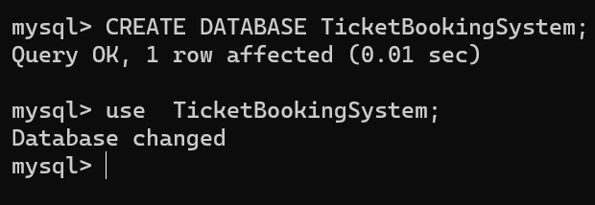

**2. Write SQL scripts to create the mentioned tables with appropriate data types, constraints, and relationships. • Venu • Event • Customers • Booking**

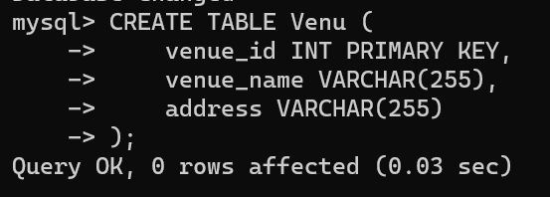

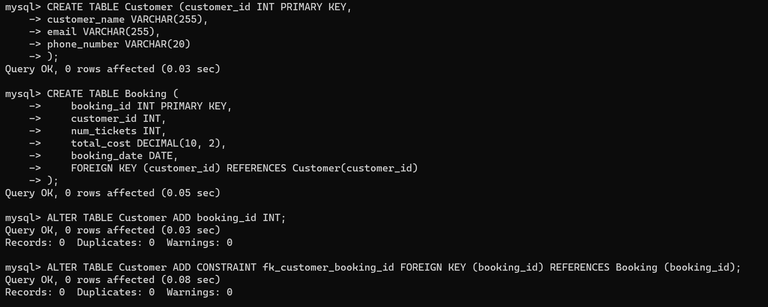

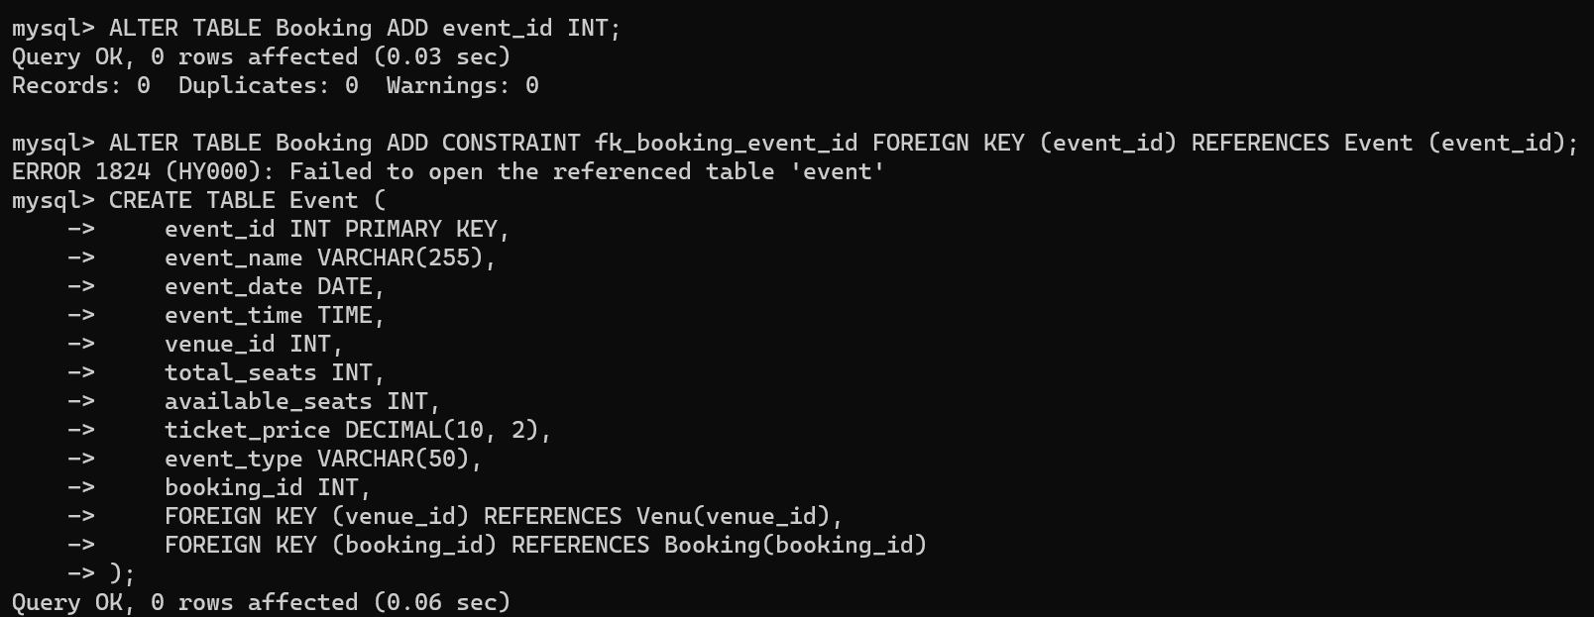

**3. Create an ERD (Entity Relationship Diagram) for the database.**

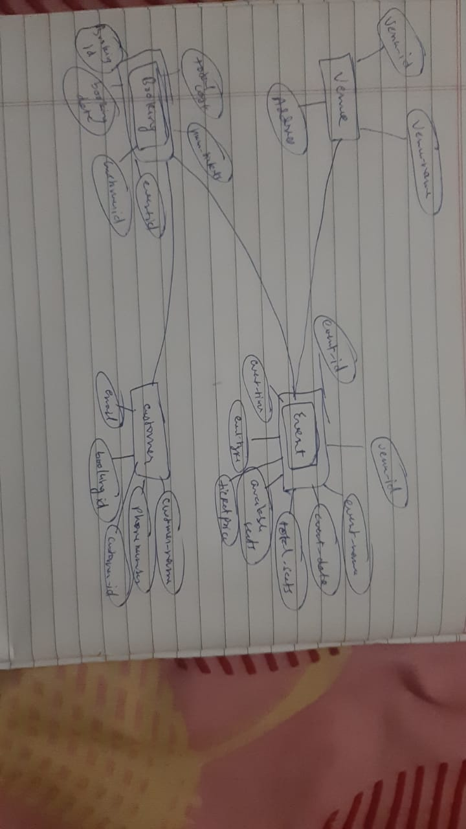

**4. Create appropriate Primary Key and Foreign Key constraints for referential integrity.**

**Tasks 2: Select, Where, Between, AND, LIKE:**

**1. Write a SQL query to insert at least 10 sample records into each table.**

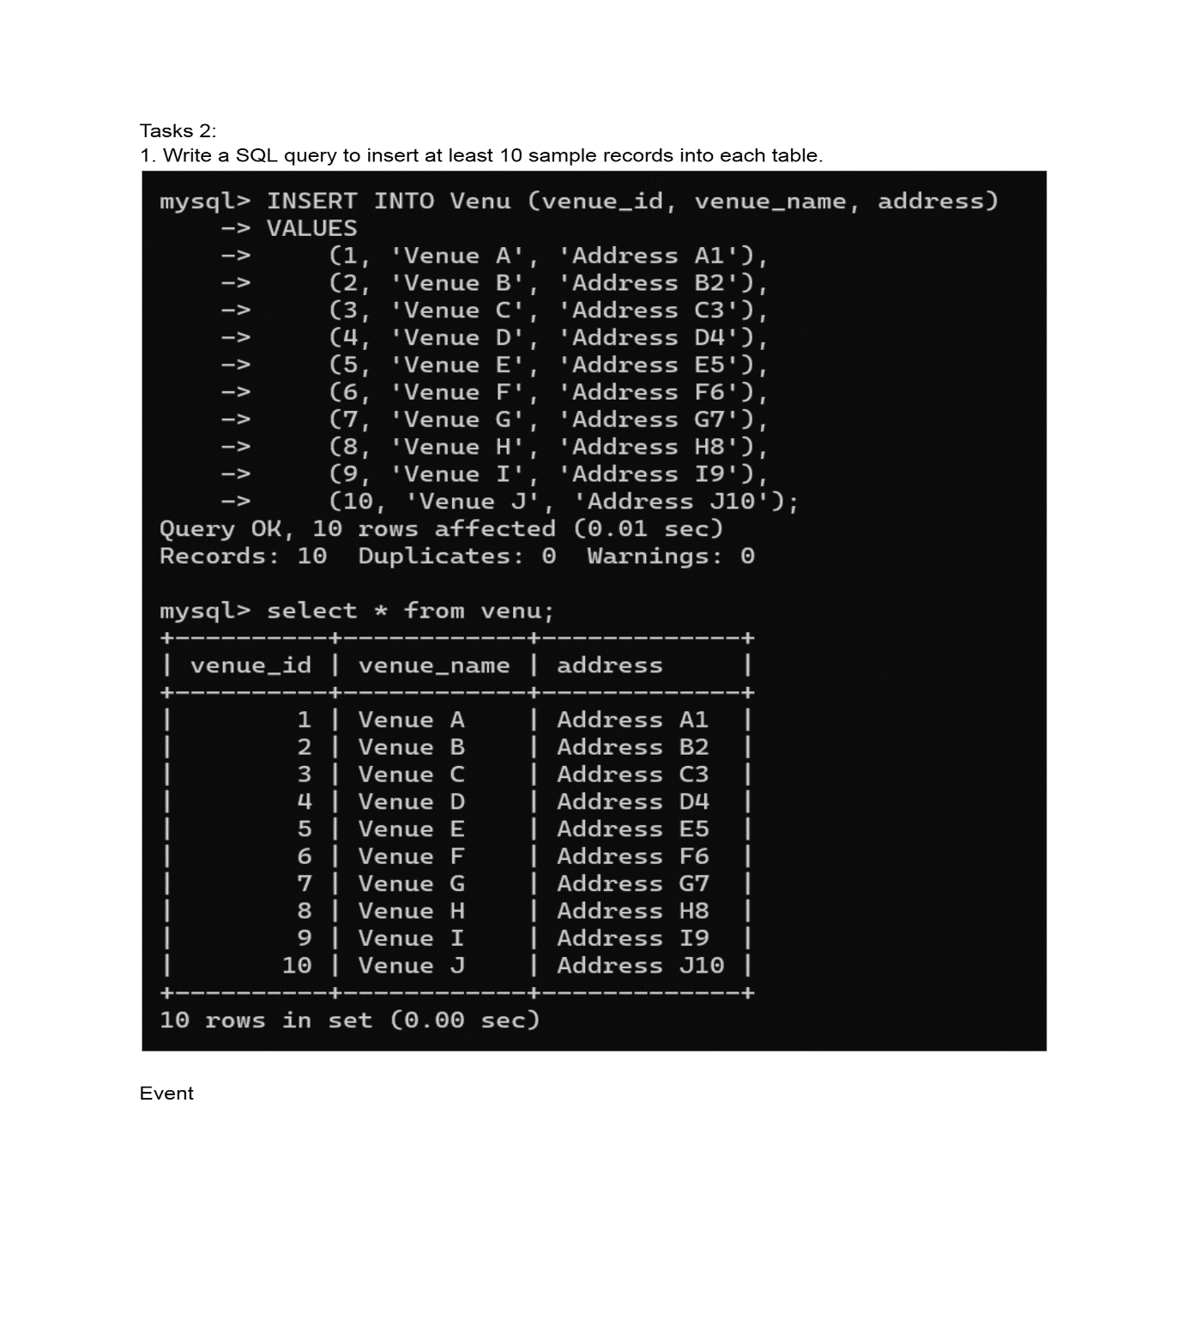

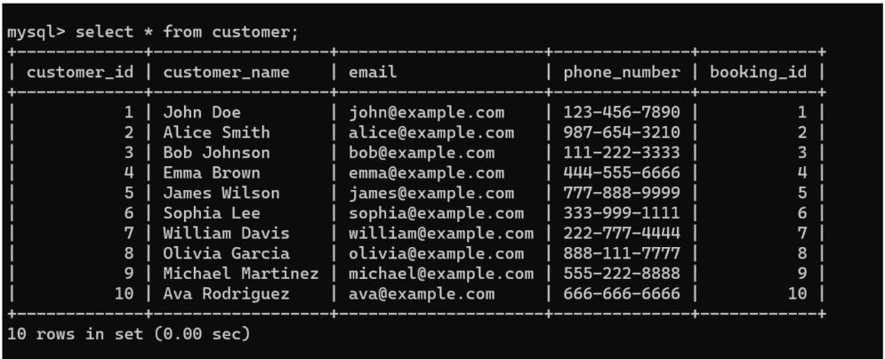

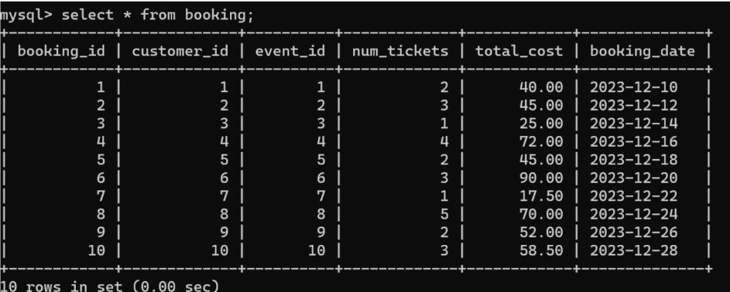

**2. Write a SQL query to list all Events.**

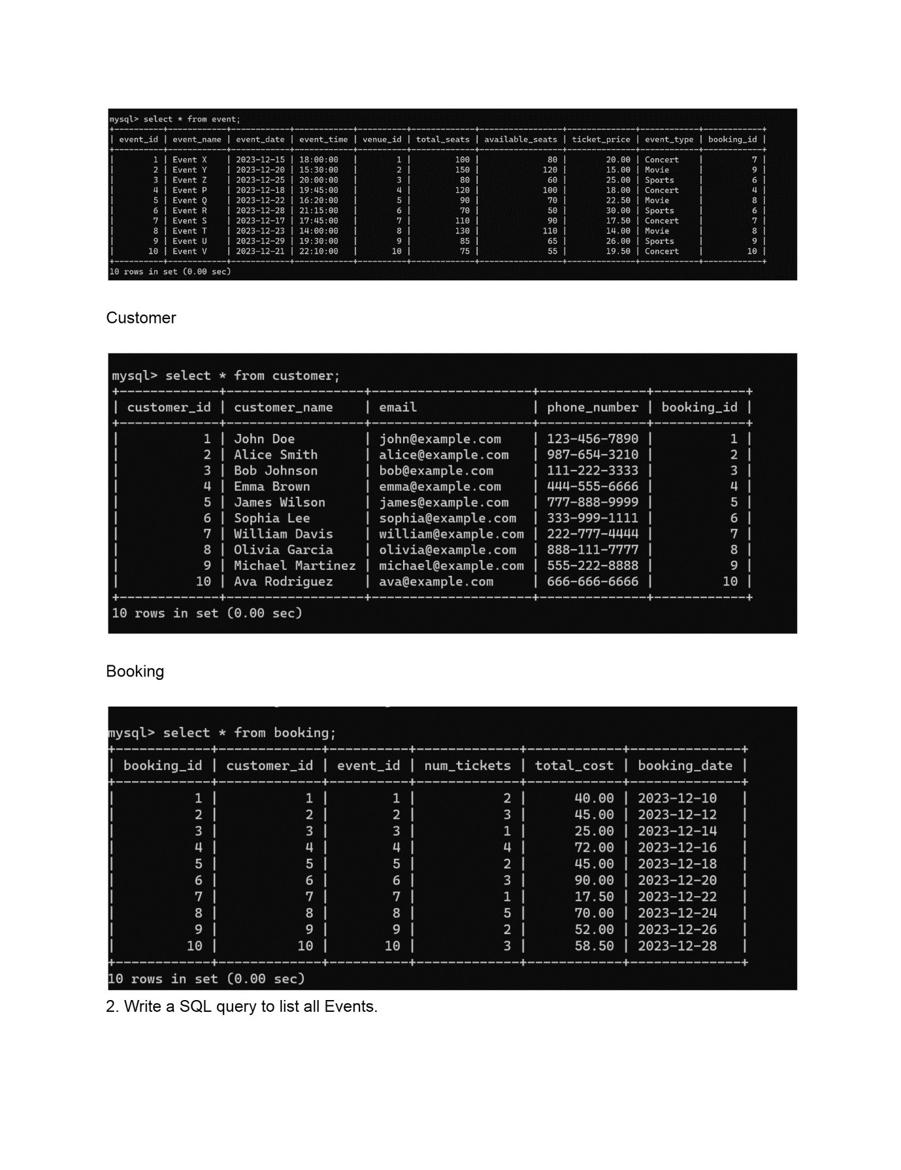

**3. Write a SQL query to select events with available tickets.**

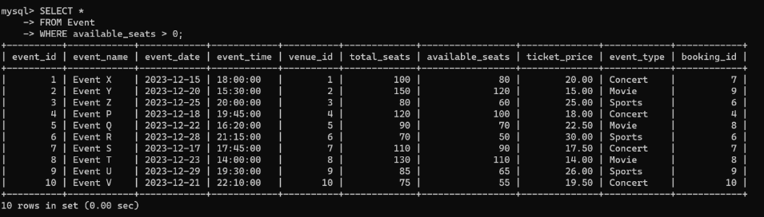

**4. Write a SQL query to select events name partial match with ‘cup’.**

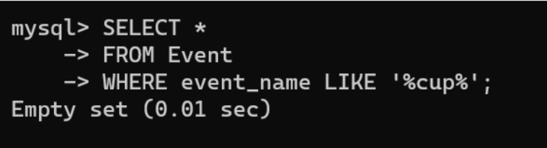

**5. Write a SQL query to select events with ticket price range is between 1000 to 2500.**

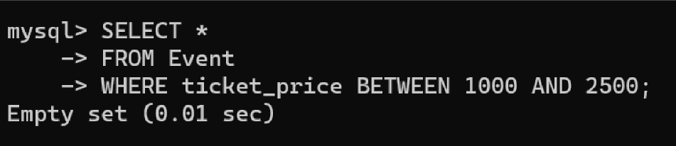

**6. Write a SQL query to retrieve events with dates falling within a specific range.**

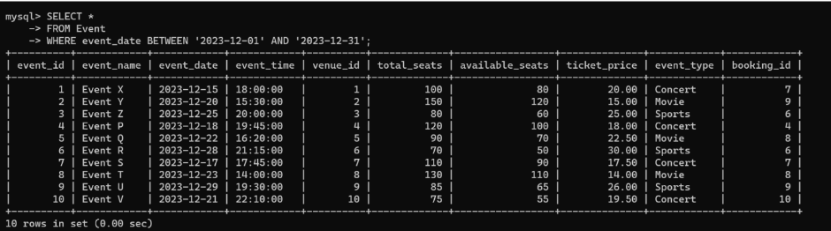

**7. Write a SQL query to retrieve events with available tickets that also have "Concert" in their name.**

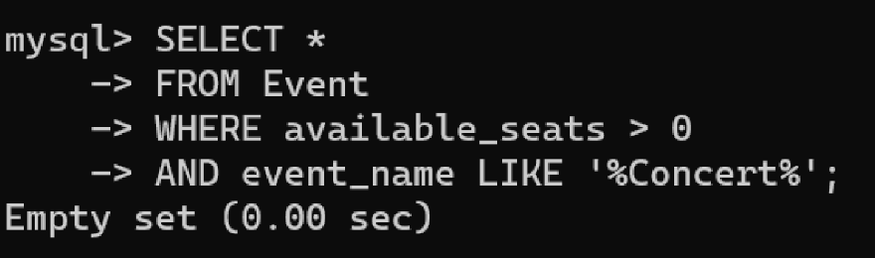

**8. Write a SQL query to retrieve users in batches of 5, starting from the 6th user.**

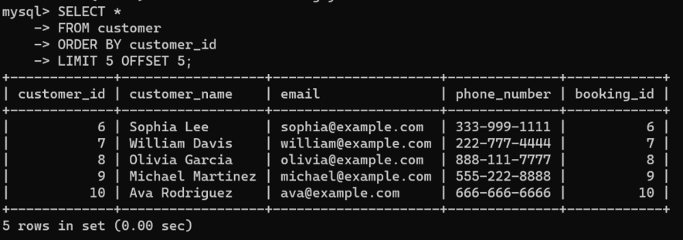

**9. Write a SQL query to retrieve bookings details contains booked no of ticket more than 4.**

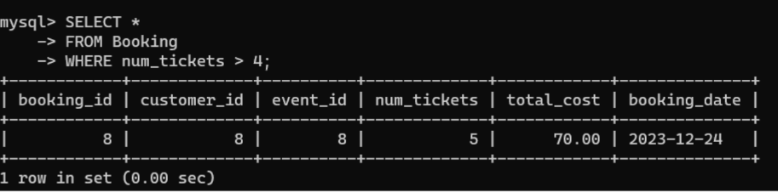

**10. Write a SQL query to retrieve customer information whose phone number end with ‘000’**

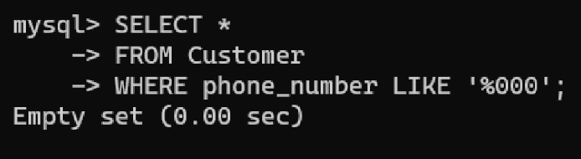

**11. Write a SQL query to retrieve the events in order whose seat capacity more than 15000.**

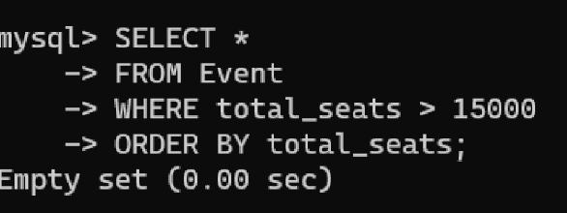

**12. Write a SQL query to select events name not start with ‘x’, ‘y’, ‘z’**

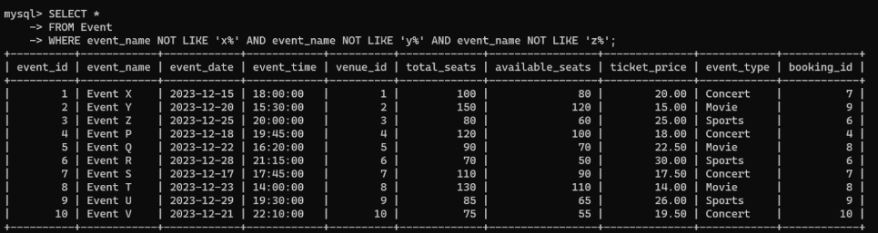

**Tasks 3: Aggregate functions, Having, Order By, GroupBy and Joins:**

**1. Write a SQL query to List Events and Their Average Ticket Prices.**

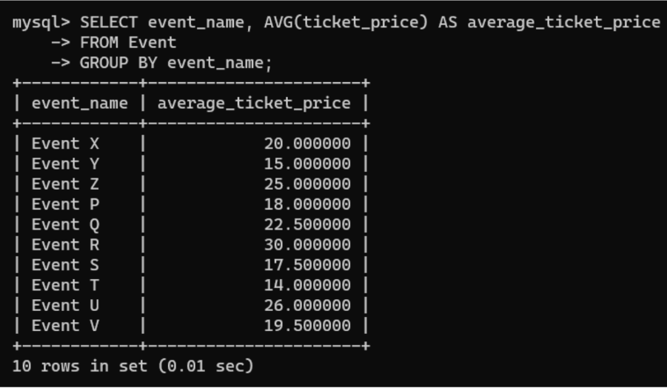

**2. Write a SQL query to Calculate the Total Revenue Generated by Events.**

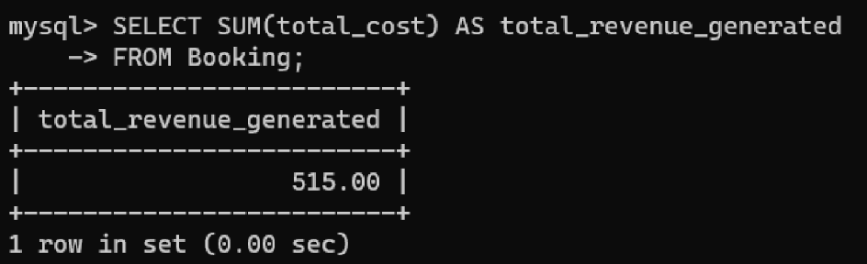

**3. Write a SQL query to find the event with the highest ticket sales.**

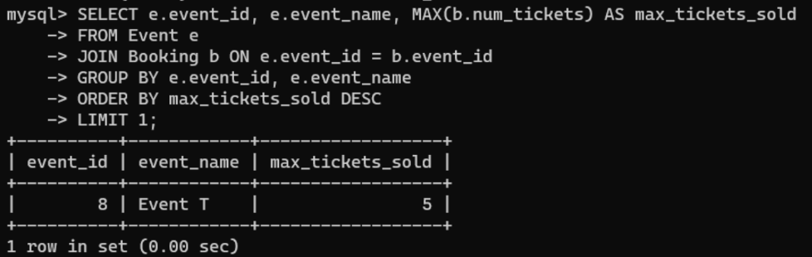

**4. Write a SQL query to Calculate the Total Number of Tickets Sold for Each Event.**

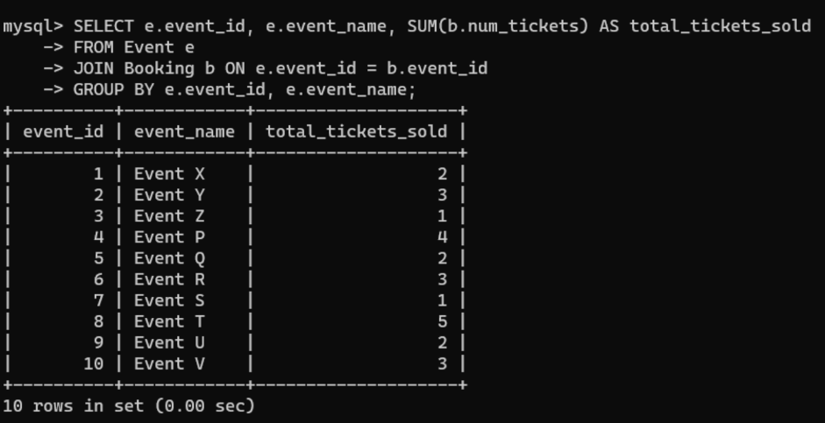

**5. Write a SQL query to Find Events with No Ticket Sales.**

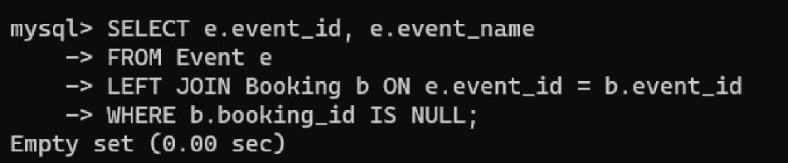

**6. Write a SQL query to Find the User Who Has Booked the Most Tickets.**

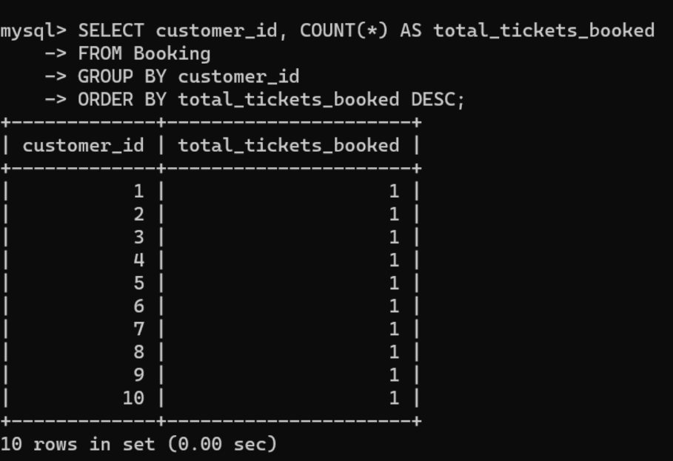

**7. Write a SQL query to List Events and the total number of tickets sold for each month.**

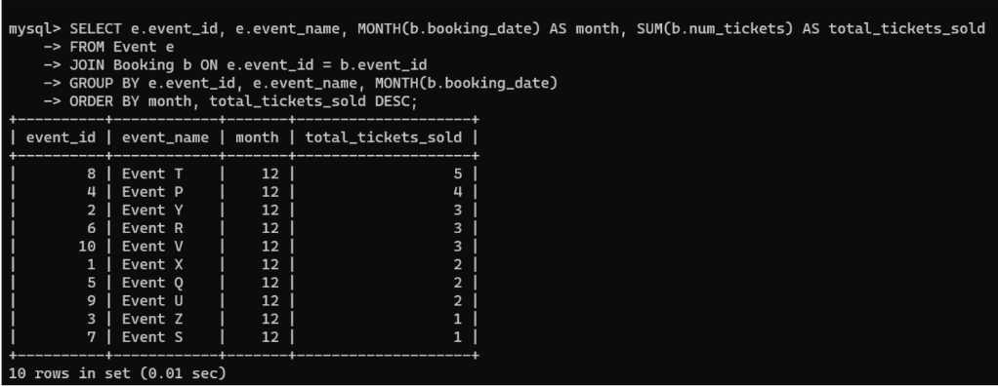

**8. Write a SQL query to calculate the average Ticket Price for Events in Each Venue.**

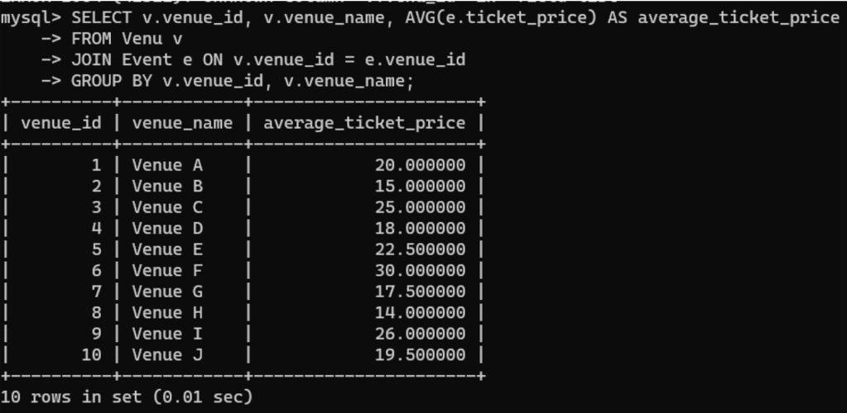

**9. Write a SQL query to calculate the total Number of Tickets Sold for Each Event Type.**

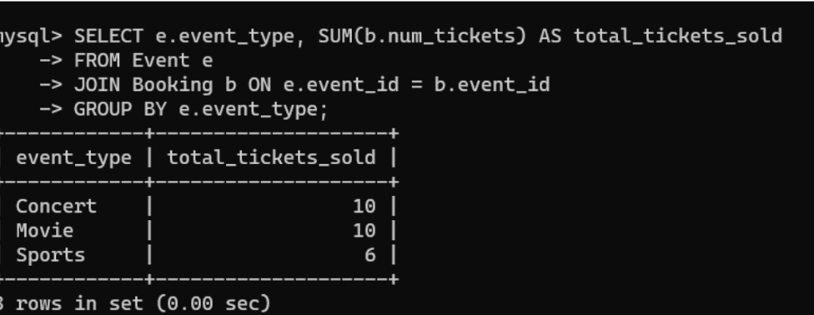

**10. Write a SQL query to calculate the total Revenue Generated by Events in Each Year.**

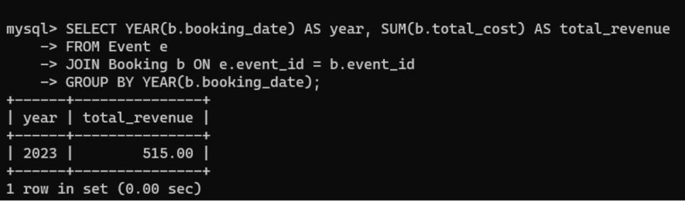

**11. Write a SQL query to list users who have booked tickets for multiple events.**

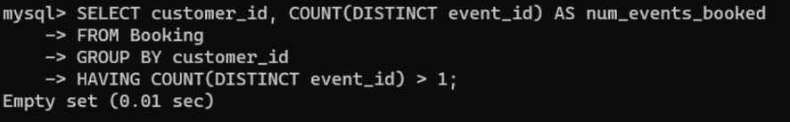

**12. Write a SQL query to calculate the Total Revenue Generated by Events for Each User.**

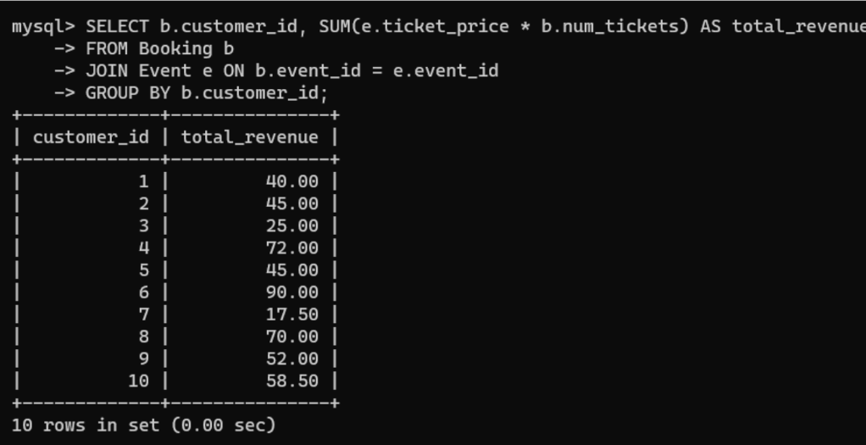

**13. Write a SQL query to calculate the Average Ticket Price for Events in Each Category and Venue.**

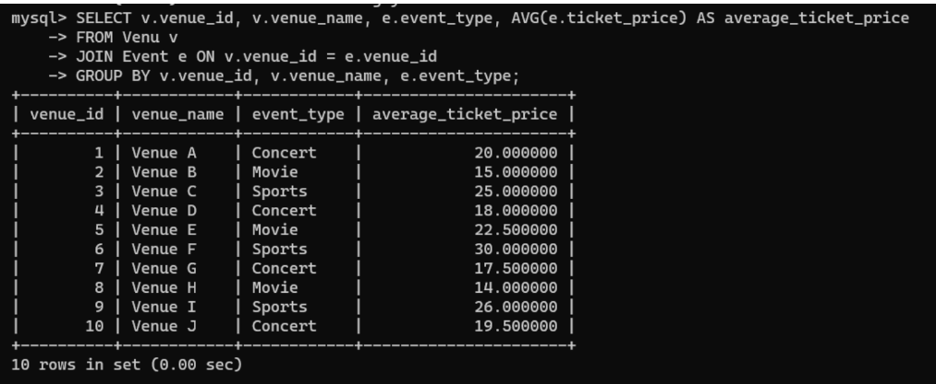

**14. Write a SQL query to list Users and the Total Number of Tickets They've Purchased in the Last 30 Days.**

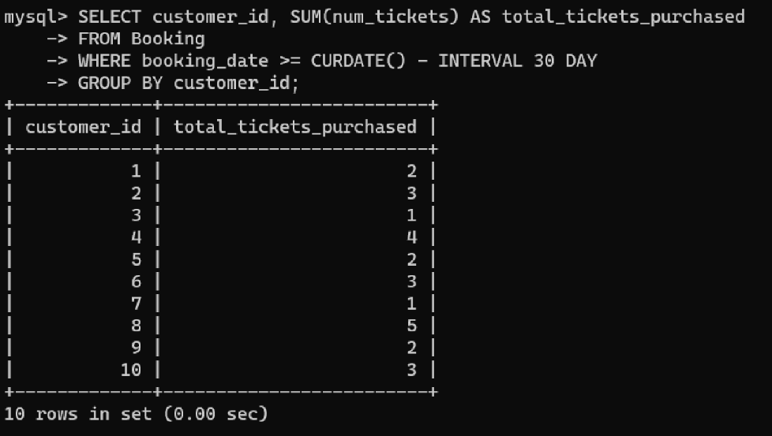

**Tasks 4: Subquery and its types**

**1. Calculate the Average Ticket Price for Events in Each Venue Using a Subquery.**

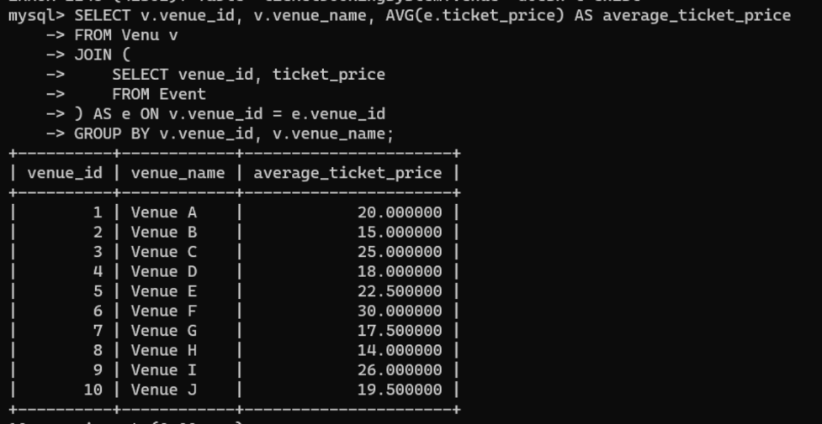

**2. Find Events with More Than 50% of Tickets Sold using subquery.**

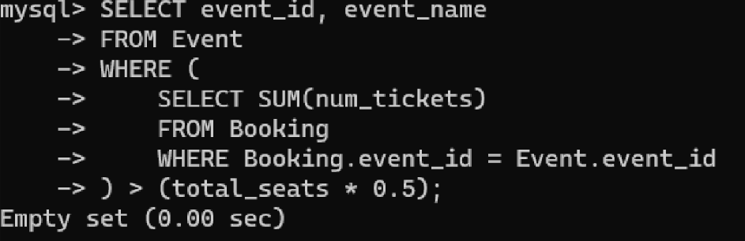

**3. Calculate the Total Number of Tickets Sold for Each Event.**

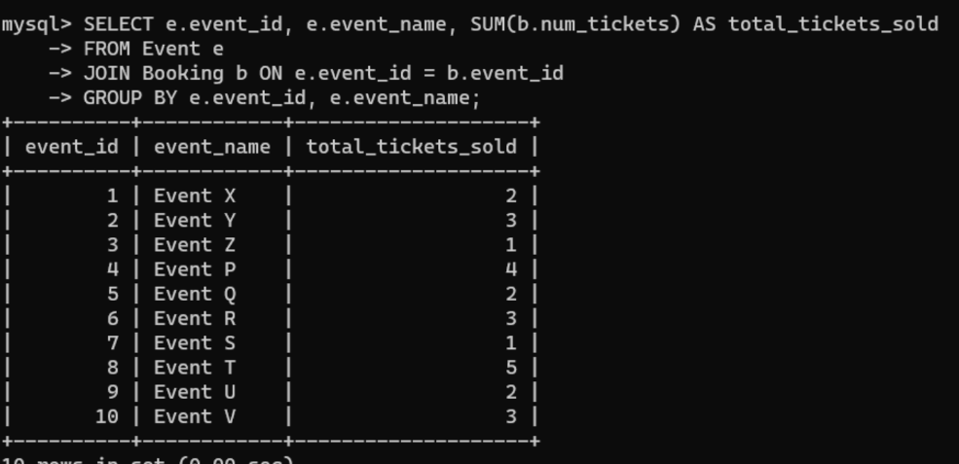

**4. Find Users Who Have Not Booked Any Tickets Using a NOT EXISTS Subquery.**

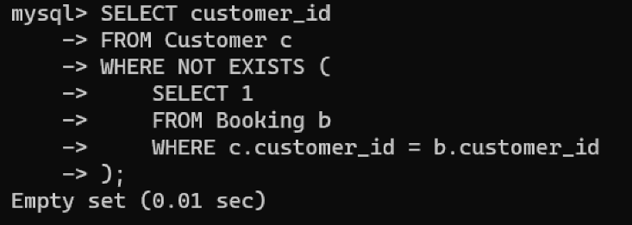

**5. List Events with No Ticket Sales Using a NOT IN Subquery.**



**6. Calculate the Total Number of Tickets Sold for Each Event Type Using a Subquery in the FROM Clause.**

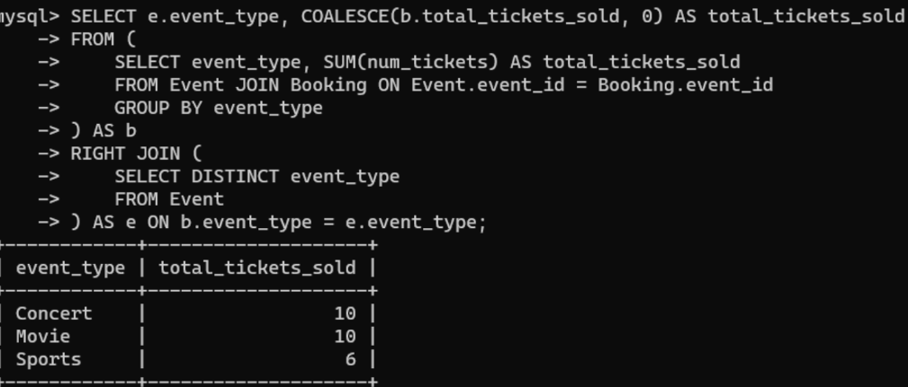

**7. Find Events with Ticket Prices Higher Than the Average Ticket Price Using a Subquery in the WHERE Clause.**

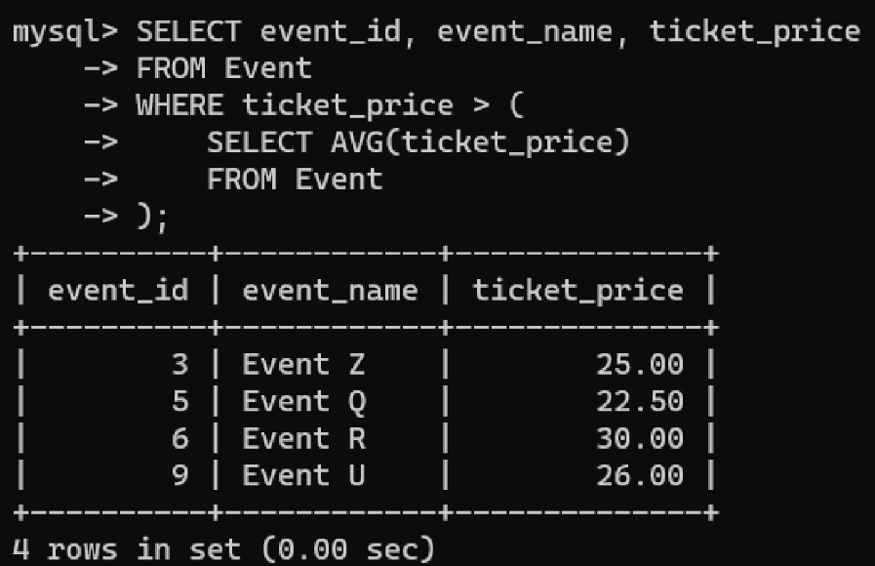

**8. Calculate the Total Revenue Generated by Events for Each User Using a Correlated Subquery.**

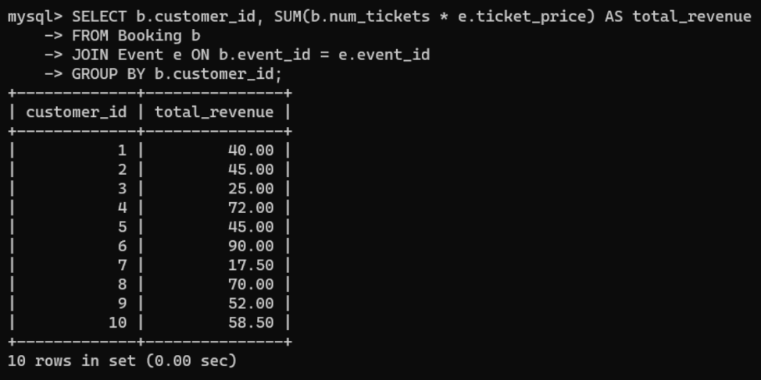

**9. List Users Who Have Booked Tickets for Events in a Given Venue Using a Subquery in the WHERE Clause.**

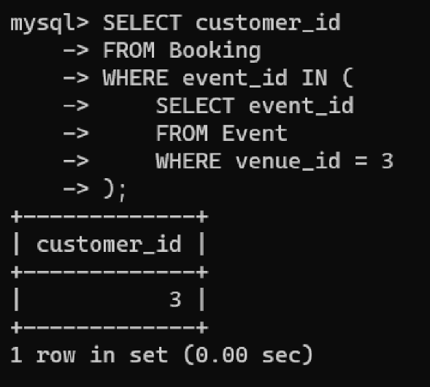

**10. Calculate the Total Number of Tickets Sold for Each Event Category Using a Subquery with GROUP BY.**

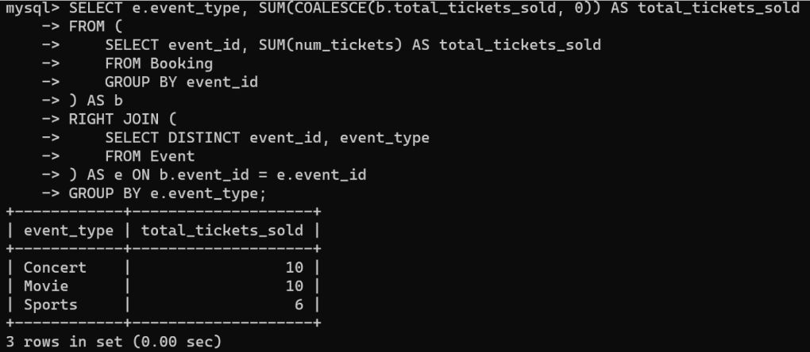

**11. Find Users Who Have Booked Tickets for Events in each Month Using a Subquery with DATE_FORMAT.**

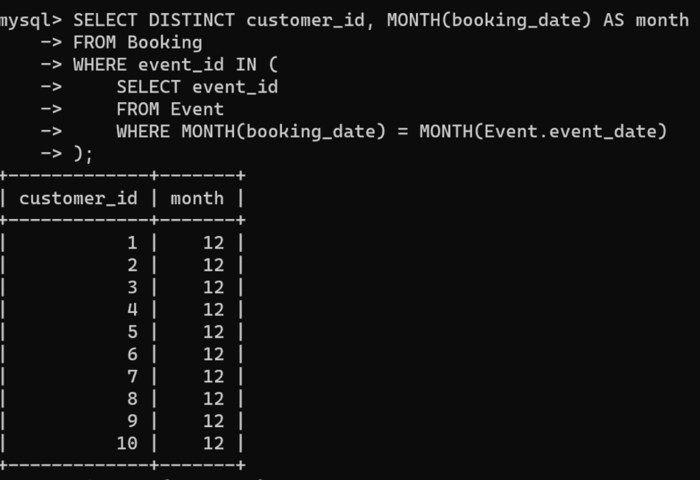

**12. Calculate the Average Ticket Price for Events in Each Venue Using a Subquery**

